Self Balancing Robot

Objective:
The primary objective is to design and construct a two-wheeled robotic vehicle that can maintain an upright position without external support.
Specific goals include:
- Mechanical Design: To build a chassis where the Center of Mass (COM) is balanced above the wheel axis.
- Sensor Fusion: To combine data from an accelerometer and gyroscope (using an MPU6050) to obtain a noise-free, accurate tilt angle.
- Closed-Loop Control: To implement a PID (Proportional-Integral-Derivative) algorithm that continuously calculates and applies the precise motor speed required to counteract gravity."
Project Motivation (Why?) :
The motivation behind this project was to bridge the gap between static programming and real-world dynamic systems. While standard robotics projects (like obstacle avoiders) operate in stable environments, a self-balancing robot represents an inherently unstable system.
I wanted to challenge myself to understand Control Theory—specifically how to maintain stability in a system that constantly wants to fail (fall over). This project serves as a practical application of the 'Inverted Pendulum' problem, a classic benchmark in control engineering used to test algorithms that are eventually applied in real-world technologies like Segways, rockets (gimbaled thrust), and bipedal humanoid robots.
Physics behind the project:
The Physics of the Inverted Pendulum
The Analogy: The Broomstick on the Palm
Imagine trying to balance a broomstick upright on the palm of your hand.
- If the broom leans forward, you must instinctively run forward to "catch" it.
- By moving the base (your hand) under the center of mass (the top of the broom), you restore balance.
- The robot does exactly this, but using wheels instead of legs.
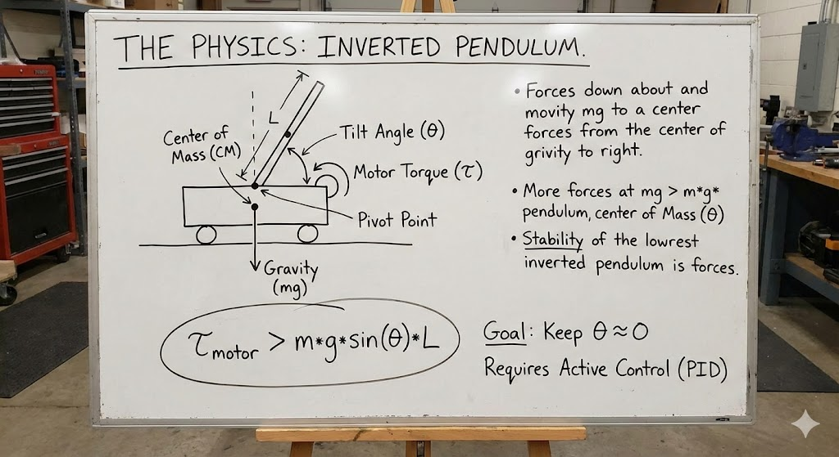
The Forces at Play
- Unstable Equilibrium: The robot exists in a state of unstable equilibrium. It is perfectly balanced only when the Center of Mass (COM) is directly vertical above the Wheel Axis (Pivot Point).
- Gravitational Torque: The moment the robot tilts by even 1 degree (let's say angle theta), gravity pulls down on the Center of Mass. Because the COM is not directly over the wheels, this creates a Torque (a twisting force).
  - Formula: tau = m \cdot g \cdot L \cdot \sin(\theta)$
  - (Where $m$ = mass, $g$ = gravity, $L$ = distance to center of mass, $\theta$ = tilt angle).
  - In plain English: Gravity is trying to rotate the robot into the ground.
- Restoring Torque ($\tau_m$): To stop the fall, the motors must generate a counter-torque.
  - The motors drive the wheels in the direction of the fall.
  - This acceleration creates a reaction force that pushes the wheels "under" the falling center of mass.
  - For the robot to recover, the Motor Torque must be greater than the Gravitational Torque.
Components:
- MPU6050
- BO Motors - x2
- Motor Driver (L293N)
- 7.4v Battery
 | Component Name | Image | Price
1. | Arduino Uno | 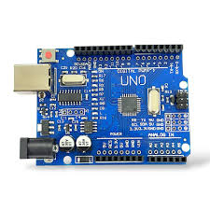 | ₹200-₹300
2. | MPU6050 | 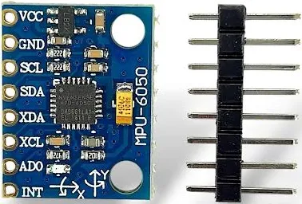 | ₹150-₹200
3. | BO Motors - x2 | 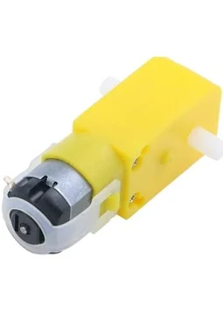 | ₹100
4. | Motor Driver (L293N) | 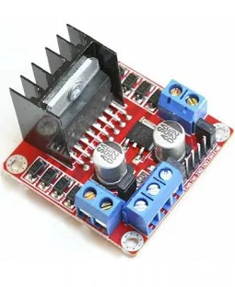 | ₹200
5. | 7.4v Battery | 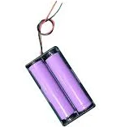 | ₹400

Code:
https://drive.google.com/file/d/1MrztL3tE2ZJ3OPQQZQ8GWYjd-vwuZwN8/view?usp=sharing
Version 2.0 (Bluetooth control):
https://drive.google.com/file/d/1PlQH-FsJB8ggDSAgfRgIGTlxw6PcYEtx/view?usp=sharing

Circuit Connections:
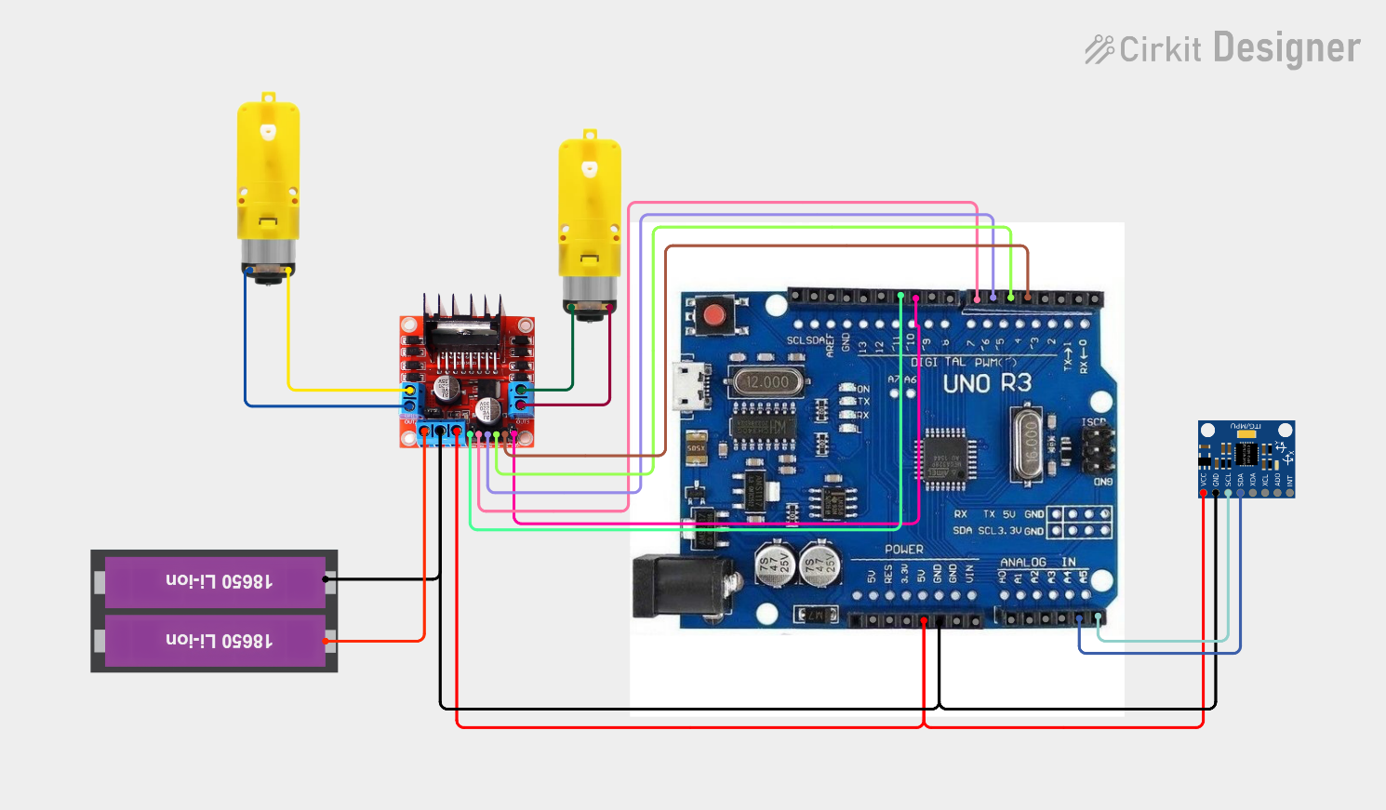
Photos:
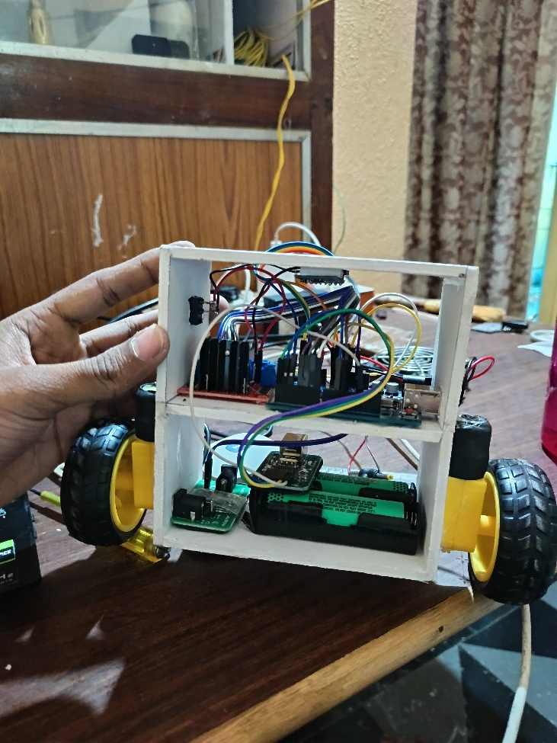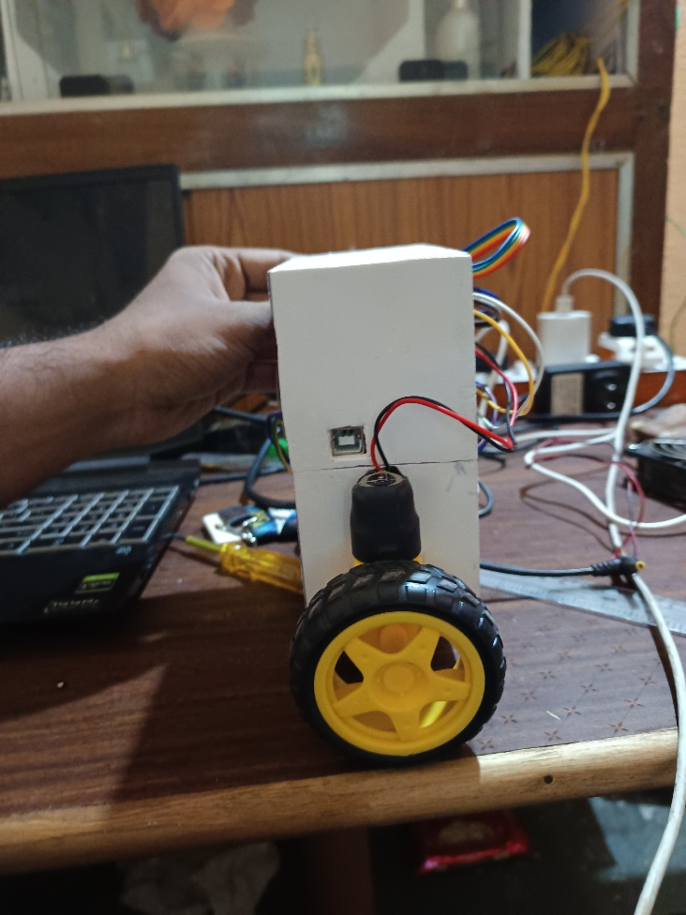
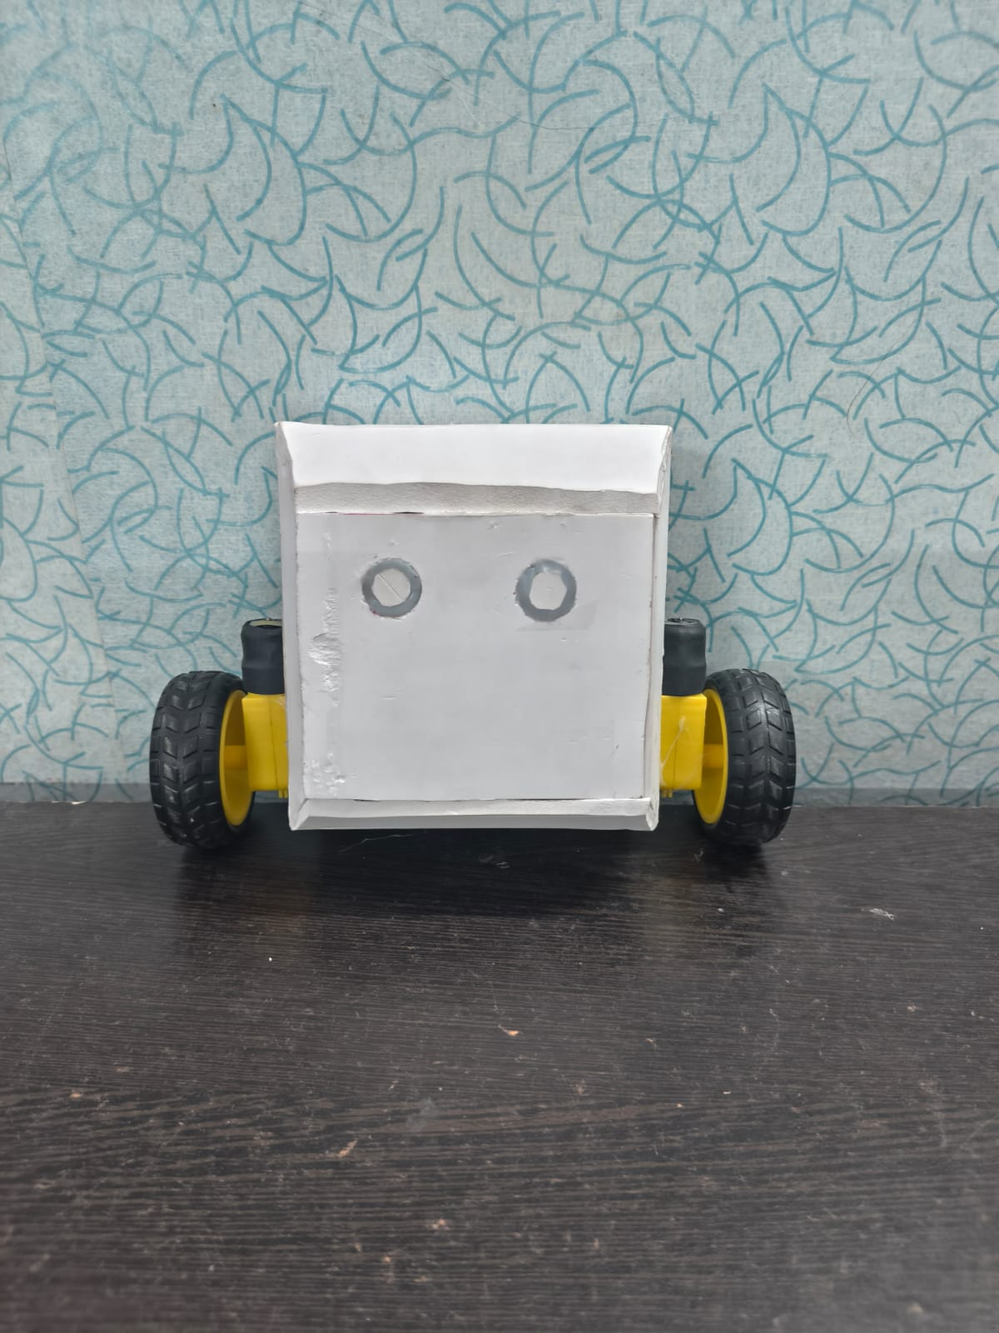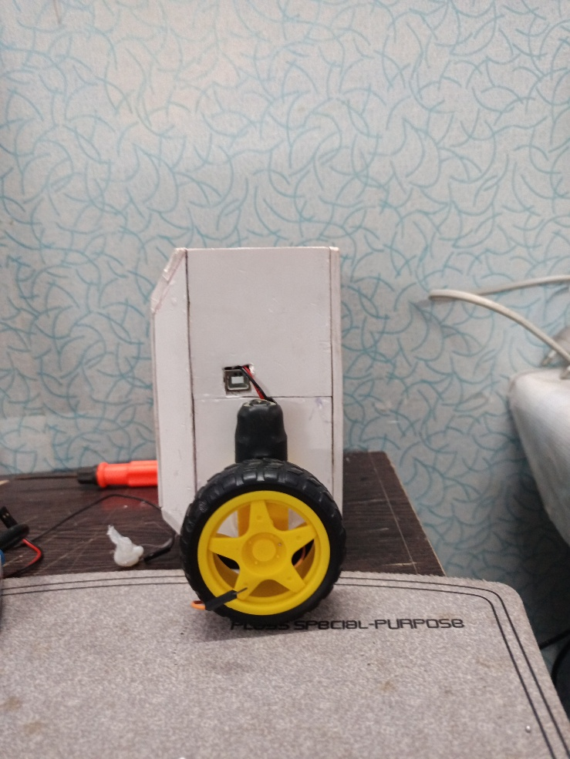
Video:
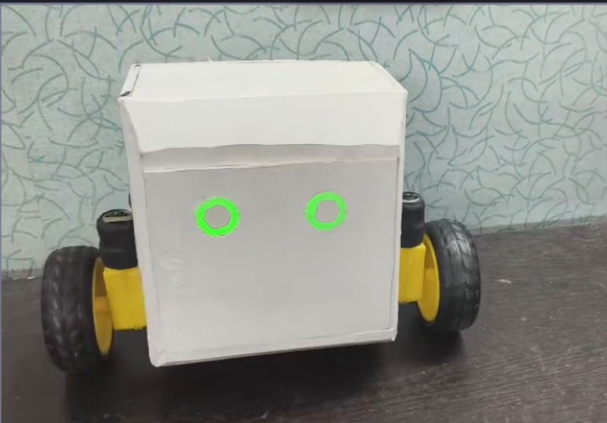
Figure 3: Demonstration of the robot recovering from a push test and Carry Load. Click image to watch video (0:43).
Version 2.0: Added Bluetooth to control the robot.
